The server ram size is 2.0GB

The location of the server is in London

The storage space dedicated to the site is 50GB

The URL of the site <https://wordpressmu-703526-2328476.cloudwaysapps.com>

The IP address is 157.245.38.17

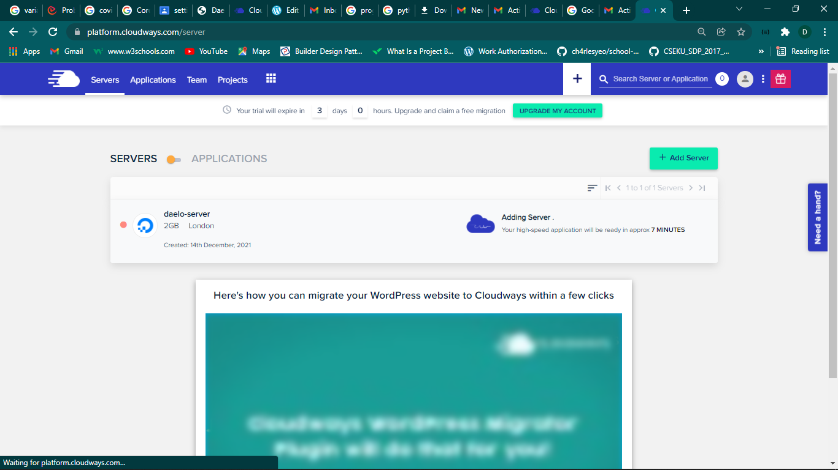

The process of virtual server creation

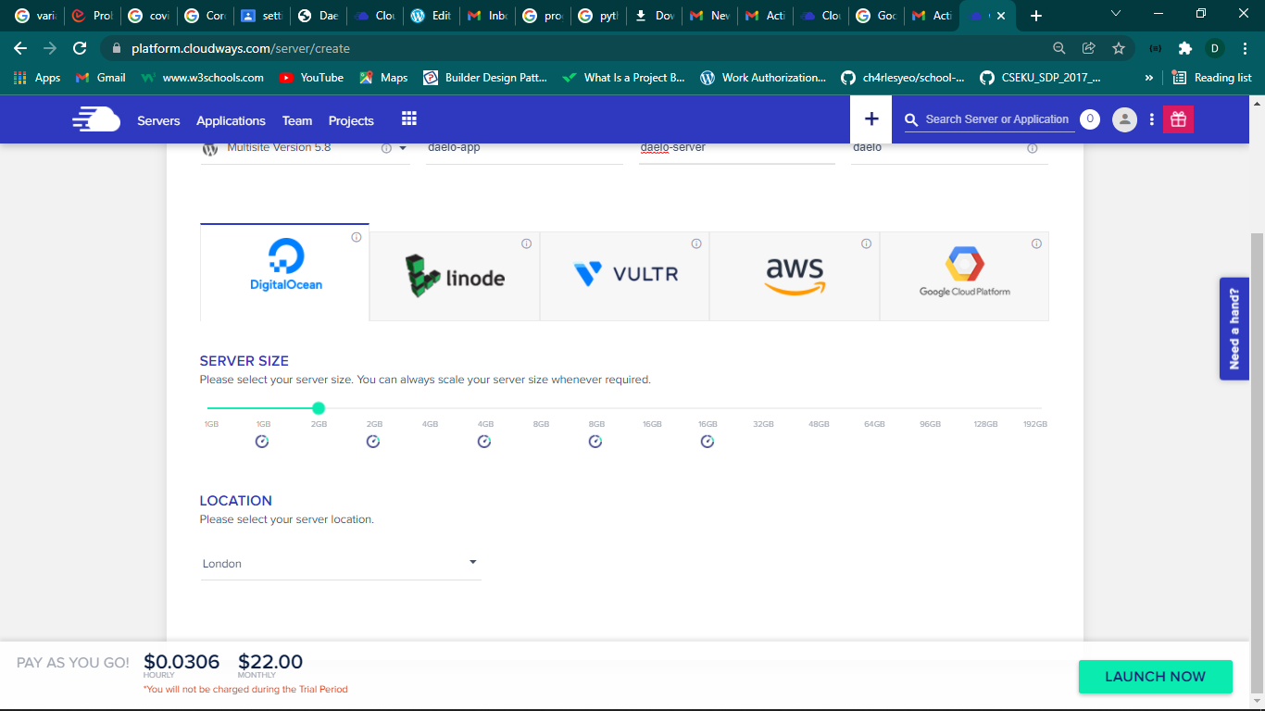

Virtual server creating process

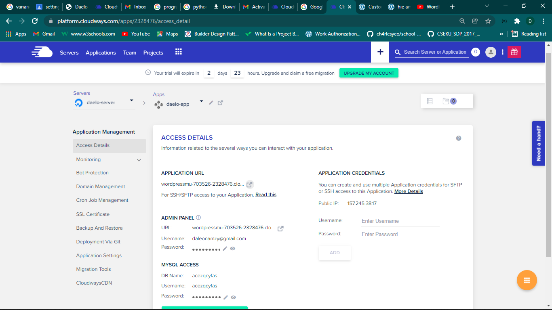

This is the account controlling the server

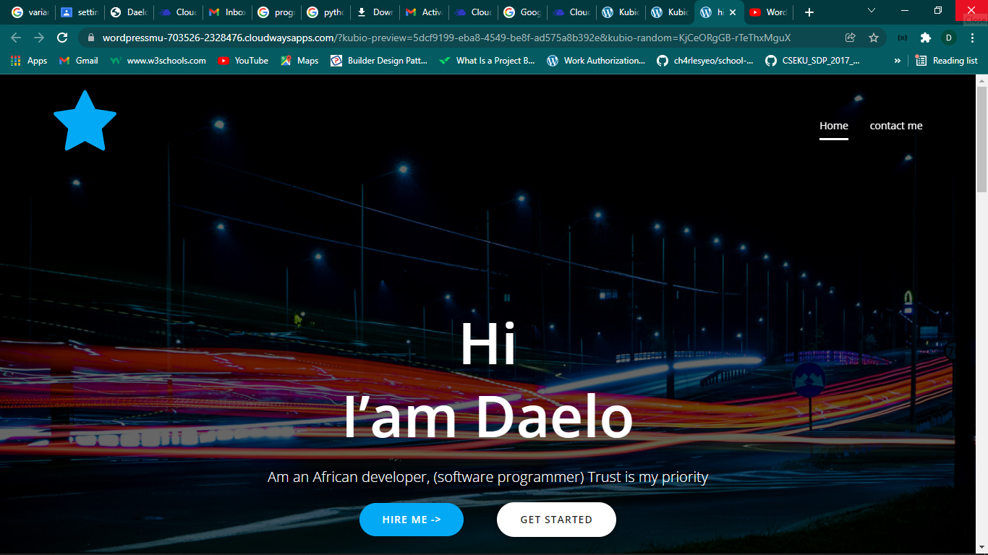

This is the home screen of the application.